JOURNAL MANAGEMENT SYSTEM
Official User Guide
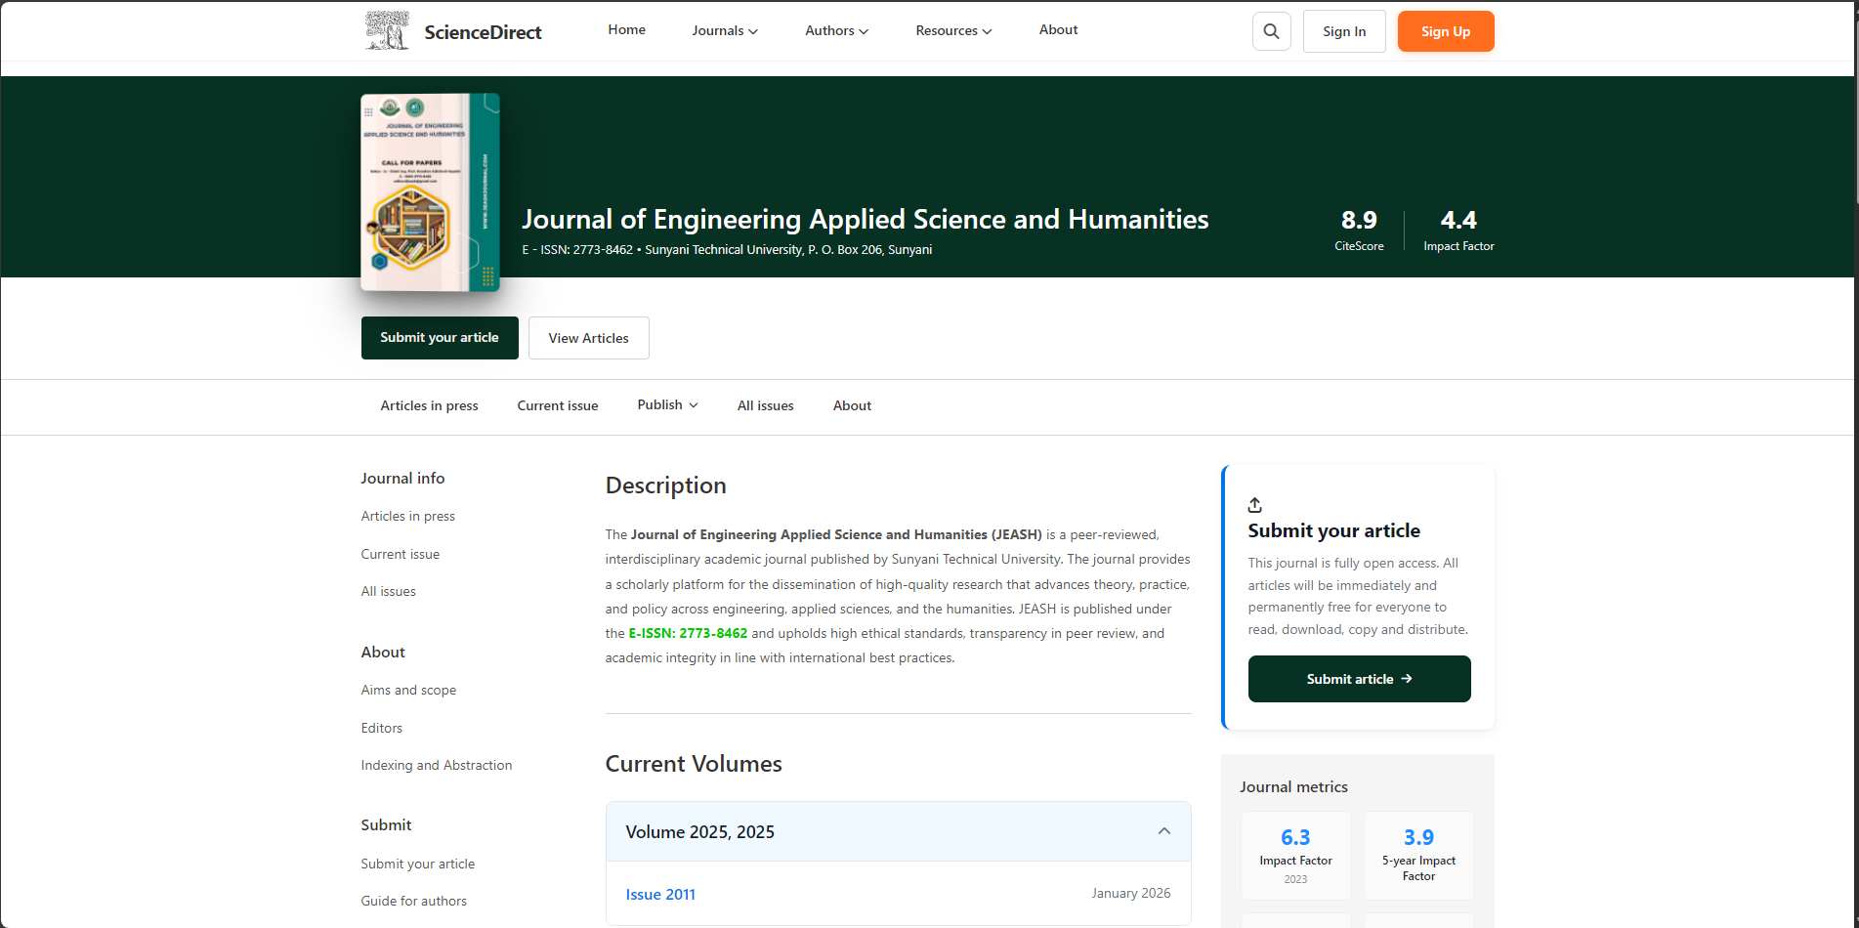
Platform URL: https://www.stujournal.academicdigital.space/
About This Guide
This document provides a complete operational manual for all user roles within the Journal Management System (JMS), including:
- Authors
- Reviewers
- Co-Editors (Copywriters)
- Admins
- SuperAdmins
Each section explains system access, workflows, responsibilities, and available tools.

1. Getting Started
1.1 Creating an Account
Visit: https://www.stujournal.academicdigital.space/register/
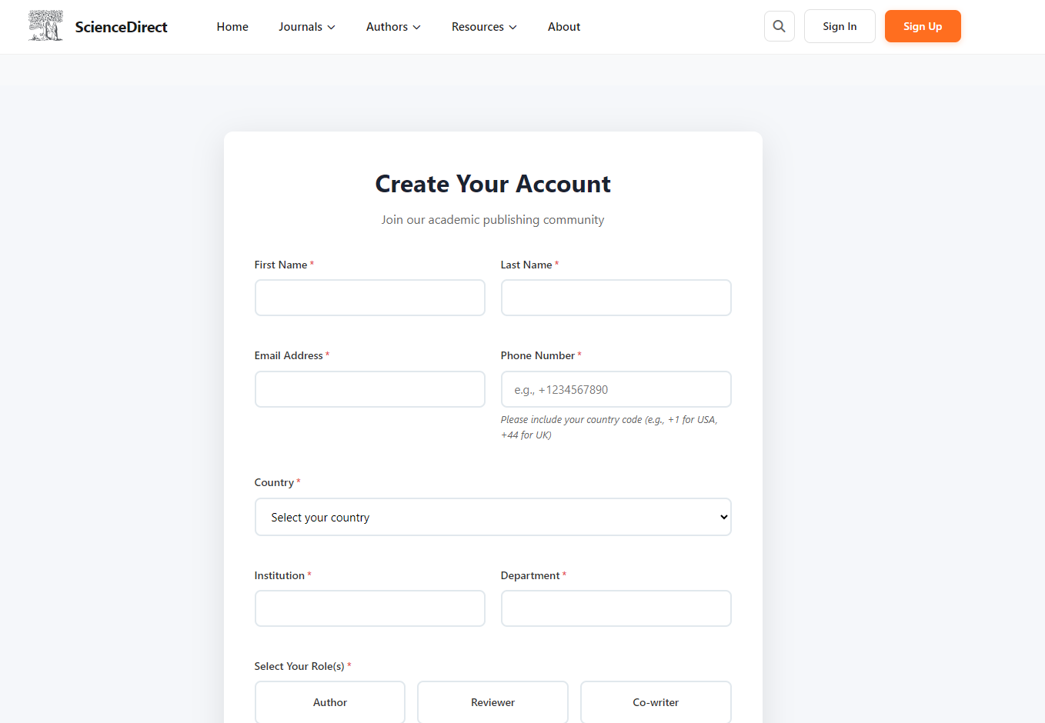
Complete the registration form in the following sections:
A. Personal Information
- First Name (Required)
- Last Name (Required)
- Email Address (Required – must be unique)
- Phone Number (Required – include country code)
B. Academic Information
- Country
- Institution
- Department
C. Role Selection
You may select one or more roles:
Role | Access | Approval
Author | Immediate | Automatic
Reviewer | Restricted | Requires Admin approval
Co-Writer | Restricted | Requires Admin approval
If Reviewer is selected, additional fields appear:
- Years of Review Experience
- Areas of Expertise
- Highest Qualification
D. Password Requirements
Your password must:
- Be at least 8 characters
- Include at least one uppercase letter
- Include at least one number
- Include at least one special character
A real-time strength meter will indicate Weak, Medium, or Strong.
E. Agreements
- Terms and Conditions (Required)
- Privacy Policy (Required)
- Newsletter subscription (Optional)
Click Create Account to complete registration.

1.2 Logging In
Visit:
https://www.stujournal.academicdigital.space/login/
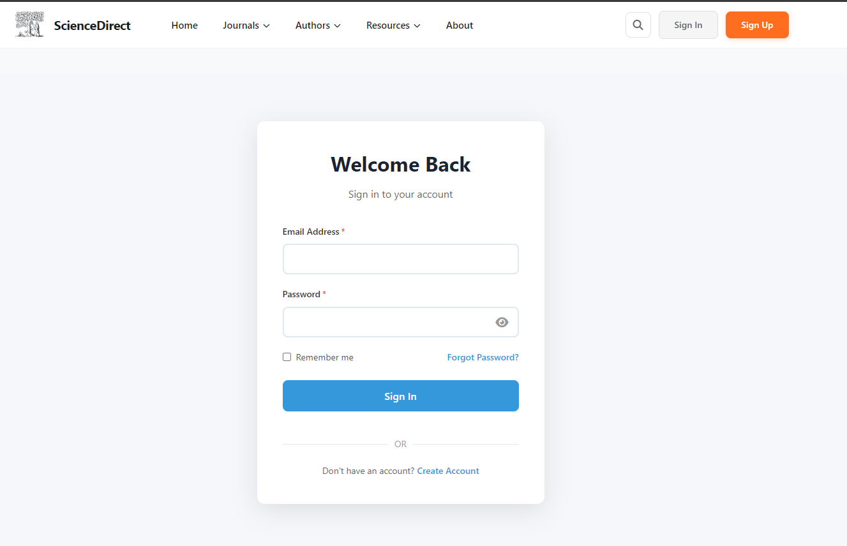
Enter:
- Email address
- Password
Click Sign In.
You will be redirected to your highest-priority dashboard.

1.3 Resetting Password
- Click Forgot Password
- Enter email
- Verify 6-digit code sent to email
- Set new password

1.4 Switching Roles
If you hold multiple approved roles, use the Role Switcher in the sidebar to move between dashboards.

1.5 System Interface Overview
Every dashboard includes:
- Sidebar Navigation (left panel)
- Top Bar (notifications & profile menu)
- Main Content Area
- Role Switcher (if applicable)

2. Author Guide
The Author role allows submission and tracking of manuscripts.
2.1 Author Dashboard
Displays:
- Total Manuscripts
- Submitted
- Under Review
- Published
Quick access to:
- New Submission
- Drafts
- My Submissions
- Publications

2.2 Submitting a Manuscript
Navigate to: https://www.stujournal.academicdigital.space/submit-manuscript/
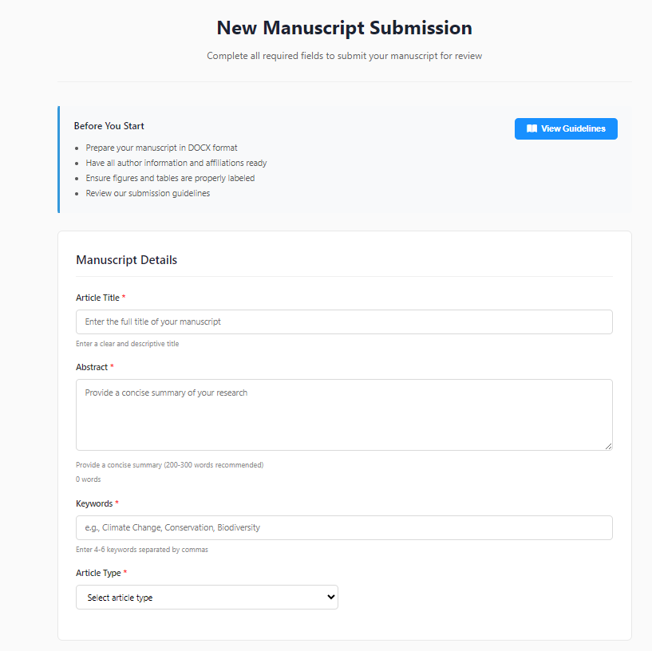
Step 1: Manuscript Details
- Title
- Abstract
- Keywords (4–6)
- Article Type
Step 2: File Upload
- Main Manuscript (DOCX required)
- Supplementary Files (optional)
Step 3: Author Information
Add:
- Co-authors
- Affiliations
- ORCID (optional)
Step 4: Declarations
- Ethics approval confirmation
- Copyright agreement
Click Submit Manuscript.
Status becomes Submitted.

2.3 Manuscript Status Meanings
Status | Meaning
Draft | Saved but not submitted
Submitted | Awaiting screening
Under Review | With reviewers
Revision Requested | Author must revise
Accepted | Payment required
Copywriting | Being edited
Published | Publicly available
Rejected | Declined

2.4 Responding to Revisions
- Open manuscript
- Review editor comments
- Upload revised DOCX
- Submit revision

2.5 Publication Payment
After acceptance:
- Click Make Payment
- Pay via Paystack
- Upon confirmation, manuscript moves to Copywriting
Invoice is downloadable as PDF.

3. Reviewer Guide
Reviewers evaluate manuscripts and provide recommendations.
3.1 Applying to Become a Reviewer
Select Reviewer role during registration.
Application requires Admin approval.

3.2 Reviewer Dashboard
Shows:
- Pending Invitations
- Accepted Reviews
- Review History

3.3 Accepting or Declining Assignments
Review invitations appear in Pending Reviews.
- Accept → 14-day review period begins
- Decline → Returned to Admin

3.4 Submitting a Review
Evaluation includes:
Scoring (1–5 scale)
- Originality
- Methodology
- Clarity
- Overall Assessment
Comments
- For Author
- For Editor (confidential)
Recommendation
- Accept
- Minor Revision
- Major Revision
- Reject
Submit review.

3.5 Reviewer Ratings
Admins evaluate reviewers on:
- Quality
- Timeliness
- Professionalism
High ratings increase assignment likelihood.

3.6 Reviewer Certificate
Downloadable PDF available after review completion.

4. Co-Editor (Copywriter) Guide
Responsible for professional language editing after acceptance.
Responsibilities:
- Correct grammar and syntax
- Ensure formatting consistency
- Verify references
- Improve clarity without altering meaning
After completing edits:
- Upload final file
- Mark assignment complete
Manuscript moves to Production.

5. Admin Guide
Admins manage the entire editorial workflow.

5.1 Editorial Workflow Tabs
- New Submitted
- Under Review
- Declined / Rejected
- Revisions Requested
- Copywriting

5.2 Admin Decisions
After review completion:
- Accept to Copywriting
- Request Revision
- Reject

5.3 Reviewer Management
Admins can:
- Assign reviewers
- Reassign
- Send reminders
- Rate reviewers

5.4 Production & Publishing
After copyediting:
- Send to Production
- Approve Production
- Assign Volume & Issue
- Publish Article
Published articles become publicly accessible.

6. SuperAdmin Guide
SuperAdmins control system configuration and journal setup.

6.1 Journal Management
Create and configure:
- Journal title
- Description
- Logo
- Editor-in-Chief

6.2 Content Management
Manage:
- Volumes
- Issues
- Article Types
- DOIs
- Guidelines
- Announcements
- Call for Papers

6.3 User Management
SuperAdmins can:
- Suspend users
- Assign roles
- Approve reviewer applications
- Approve co-editor applications
- Manage admin accounts

6.4 Financial & System Settings
Configure:
- Publication Fee
- Paystack Keys
- Theme color
- Logo and branding
- Journal metrics

7. Manuscript Lifecycle Overview
- Submission
- Screening
- Peer Review
- Revision (if required)
- Acceptance
- Payment
- Copyediting
- Production
- Publication
All status transitions are recorded for audit purposes.

8. Public Pages
Accessible without login:
- Homepage
- Journals
- Volumes
- Issues
- Current Issue
- Articles
- Editors
- Guidelines
- Announcements
- Call for Papers
- Indexing & Abstraction

9. Frequently Asked Questions
Can one user have multiple roles?
Yes. Use the Role Switcher.
How long does review take?
Reviewers have 14 days. Full process: approximately 4–12 weeks.
What file format is required?
Main manuscript must be DOCX.
How is payment handled?
Via Paystack gateway.
Can Admin override reviewer decisions?
Yes. Final decision rests with Admin or Editor-in-Chief.

Conclusion
The Journal Management System provides a fully integrated workflow for:
- Manuscript submission
- Peer review
- Editorial management
- Financial processing
- Copyediting
- Publication
For technical assistance, contact your system administrator.

